**Oyster Task Force Meeting**

**Tuesday, June 12, 2024, 10:00am**

**New Orleans Lakefront Airport**

**6001 Stars and Stripes Blvd.**

**New Orleans, LA**

**I.** Pledge of Allegiance

**II.** Roll call and introduction of guests

**Voting Members Present:**

Brandt Lafrance

Al Sunseri

Mitch Jurisich

Dan Coulon

Brad Robin

Sam Slavich

Peter Vujnovich

Matthew Slavich

Jakov Jurisic

**Voting Members Absent:**

Shane Bagala

Tracy Collins

Brandon Debarge

Willie Daisy

Steve Pollock

**Non-Voting Members Present:**

Brian Lezina

Robert Caballero

**Non-Voting Members Absent:**

Edward Skena

Kyle Balkum

**III.** Peter Vujnovich motioned to approve the March 19, 2024 meeting minutes, 2nd by Brad Robin. Motion carries.

Brad Robin motioned to approve the June 12, 2024 meeting agenda, 2nd by Peter Vujnovich. Motion carries.

**IV.** Treasury Report

Remaining Fund Balance- $573,901

Remaining Budget Balance- $14,026

May tag sales- 123,600

Peter Vujnovich motioned to approve the treasury report as presented, 2nd by Brad Robin. Motion carries.

Al Sunseri motioned to increase the OTF budget for professional services by an additional $100,000 to make it an even $200,000, 2nd by Brad Robin. Motion carries.

V. Committee Reports

A. Public Private Oyster Seed Grounds Committee report- no report

B. Enforcement Report- the following written report was provided to the task force

March 11th- June 6th

**Region 4** (Iberia)

Iberia

1-56:422E-Violate Oyster Cargo Vessel Regs

1-56:303.7-Fail to complete trip tickets

**Seizures:** 150 Sacks

**Region 5** (Calcasieu, Cameron, Vermillion)

Vermillion

1-56:449E-Possession of less than 10% untagged or improperly tagged oysters

1-56:430B(1)-Harvest oysters from unmarked lease

1-40:4A-Violate Sanitation Code(logbook)

1-40:4A-Violate Sanitation Code(refrigeration)

2-40:4A-Violate Sanitation Code(Vessel Sanitation Requirements)

1-56:306.5-Fail to maintain records

**Seizures:** 6 Sacks

Cameron

1-56:303.1.1-Commercial fresh products licensee fail to report or maintain records

1-56:303.1.1-Commercial fisherman sell to consumer w/o fresh products license

3-56:444-Failure to display proper number on vessel (warnings)

**Seizures:** 46 Sacks

**Region 6**: (Terrebonne, Lafourche, Grand Isle)

Terrebonne

14-56:326.3 Not abiding by Commission Rules & Regs. (Fail to report oyster harvest for seed ground)

4-56:433.1 Violate seed ground vessel permit regulations.

1-56:304 A Take or possess commercial fish without vessel license.

1-56:422E Violate Oyster cargo vessel regulations

1-56:435 Use illegal dredge (dive plate on seed ground)

2-56:424A (1) Violate commission action on state seed ground. (untagged sacks)

1-56:303.2A Fail to have commercial license in possession.

1-40.4A Violate sanitation code (log book)

1-40:4A Violate sanitation code (Refrigeration)

**Seizures:** 260 sacks

**Region 8**: (Jefferson, Plaquemines, St. Bernard, Orleans)

St. Bernard

2 -56305 A – Take Commercial Fish Without Commercial Gear License

1- 56: 449A – Failure to fill out oyster tags correctly.

1- 40:636 – Adulterated/Misbranded Seafood

1- 40: 4A – Violate Sanitation Code (Log Book)

**Seizures:** 88 Sacks

Plaquemines

1-RS 56:57.3 - Obtain license by fraud.

1-56:305 A – Take Commercial Fish Without Commercial Gear License.

1-56:444 –Failure to Display Proper Number on Vessel.

1-RS 40:4 A – Violate Sanitation Code – (refrigeration)

**Seizures:** 113 Sacks

C. Legislative Committee Report- no report

D. Legal Committee Report- no report

E. Research Committee Report- no report

F. Coastal Restoration Committee Report- no report

G. Marketing Committee Report- Anna Koehl provided an update; would like to designate a committee for the ‘Let The World Be Your Oyster’ event to discuss budget, sponsorships and partnerships, also need a marketing meeting to look into the budget for video

Patrick Banks stated that a marketing meeting would be good since the department would need very specific information to bring to the legislature to increase the budget; Jakov Jurisic stated that he has had numerous attempts to reach out to the SPMB and has not heard back

H. Health Committee Report- Jennifer Armentor provided the health report;

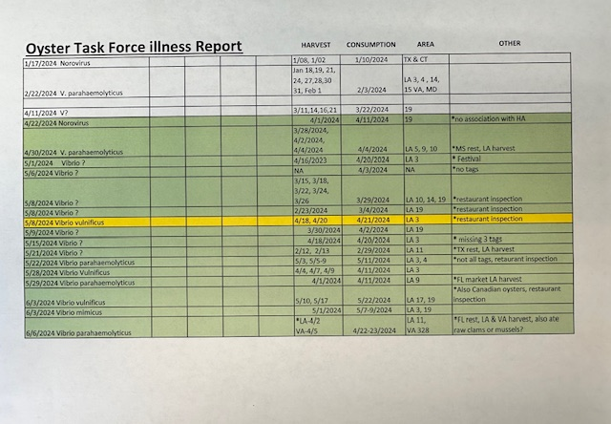

HASSP plan is a guideline for people who process seafood to follow, LA is one of the only states that does their own HACCP plan, you do not have to follow the state’s HACCP plan, you have the ability to write your own just have to meet the key guidelines in the model ordinance

I. Aquaculture Committee Report- no report

J. Joint Task Force Working Group Report- no report

**VI.** New Business

1. Robert Caballero provided the task force with an oyster season update

**Final Oyster Season Summary:** Below is a comprehensive 2023/2024 Oyster Season update.

**Daily Reporting**

The table below contains the daily harvest reporting data. It appears that some of the phone reporting converted over to the eReporting application. Also, the eReporting application has many of the out of state vessel permit users. Total vessels reporting by the end of the season is estimated at 98% compliance, by comparing total harvest vessels observed by biologists versus total vessels complying with daily reporting. Of the 207 vessels reporting daily, 87% reported by phone and 26% reported using the new eReporting app.

|  |  |  |
| --- | --- | --- |
| **Total Vessels Reporting** | **202** | **98%** |
| **Total Vessels Observed** | **207** |  |
| **Total Vessels Phone call** | **175** | **87%** |
| **Total Vessels eReporting** | **52** | **26%** |
| **Vessels Switching Methods** | **24** | **12%** |

**POSG East of Mississippi River and North of MRGO**

There was a total of 6,395 sacks reported harvested through the daily reporting requirement. Biologist boarding run estimates put the harvest at around 10,385 sacks. There is a 38% difference in daily reported harvest versus boarding run harvest estimates for this area.  Most of the harvest has taken place In LDH areas 2 & 3, in the northern Biloxi Marsh area. However, two reefs have exceeded the individual reef harvest thresholds. The 3-Mile Pass and Shell Point cultch plants have both exceeded their 50% Fishery Management Plan harvest threshold and Shell Budget harvest thresholds this season. Closure of these two reefs occurred ½ hour after sunset on 12/03/2023. Harvest in this area has dropped off since the end of December, with only a few boats still participating sporadically. Daily reporting compliance by harvesting vessels is compiled by comparing the total harvesting vessels observed by biologists versus the total vessels complying with daily reporting. The oyster season compliance estimates were 72% of the vessels reporting and 72% of harvested sacks reported.  After quality control checks, there were 73 unique vessels observed by biologists and 58 unique vessels reporting, thus having 79.5% of the vessels harvesting in this area reporting daily harvest.

**POSG East of Mississippi River and South of MRGO**

A total of 2,052 sacks have been reported harvested through the daily reporting requirement. Biologist boarding run estimates put the harvest around 3,078.5 sacks. There is a 33% difference in daily reported harvest versus boarding run harvest estimates for this area. All of the Harvest for this area is coming from around Lake Fortuna and the cultch plant located there. Most of the harvest occurred in the first two weeks of the season. Daily reporting compliance by harvesting vessel estimates for the season are at 71% of the vessels reported and 60% of harvested sacks reported.  After quality control checks, there were 16 unique vessels observed by biologists and 26 unique vessels reporting, and therefore; unable to determine percent vessels harvesting in this area reporting their daily harvest.

**Sister Lake**

This area had a one-day bedding season on October 9, 2023. 1,800 barrels of oyster seed resource was reported harvested and biologists’ estimated bedding harvest at 3,650 barrels. During the one day bedding season, daily harvesting reporting compliance was 45% of the vessels witness in Sister Lake. Estimates for non-living reef material removed during bedding sampling ranged between 0.12-7.05 percent. There were 48,457 sacks of market oysters reported harvested through the daily reporting requirement. Biologist boarding run estimates put the market harvest around 69,288 sacks. There is a 30% difference in daily reported harvest versus boarding run harvest estimates for this area. The harvest locations varied among the three separate openings and this area is historically managed through repeated smaller openings. LDH closure lines extended into Sister Lake, closing some of the more productive northern reefs from November-February; due to this, Sister lake was opened in October to allow access to the northern productive reefs. Daily reporting compliance by harvesting vessel estimates varied over the season for each opening, but finished during the third opening at 84% of the vessels reporting and 87% of harvested sacks reported.  After quality control checks, there were 150 unique vessels observed by biologists and 147 unique vessels reporting, thus having 98% of the vessels harvesting in this area complying with the reporting daily harvest by the end of the oyster season.

The 1st Sister Lake opening was for 20 fishable days, from October 10 through October 30, with118 vessels participating in this harvest opening. There were 24,632 sacks of market oysters reported harvested through the daily reporting requirement. Biologist boarding run estimates put the market harvest at around 34,921 sacks. There was a 29.5% difference in daily reported harvest versus boarding run harvest estimates for the 1st opening. Most of the harvest came from the northern side of the lake and the cultch plants around mid-lake. Daily reporting compliance by harvesting vessel for the oyster season averaged 61% of the vessels reported and 62% of harvested sacks reported.

The second opening of Sister Lake was from March 4 through March 10, for 7 fishable days with 6,536 sacks of market oysters reported harvested through the daily reporting requirement. Biologist boarding run estimates put the market harvest around 16,182 sacks. There was a 60% difference in daily reported harvest versus boarding run harvest estimates for this area. Most of the harvest came from the cultch plants in the lake, Grand Pass reef, and the Bayou Dularge reef area. There were 107 vessels that participated in this harvest opening, with many new vessels participating for first time in the current season. The daily reporting compliance by harvesting vessel for the second opening averaged 46% of the vessels reported and 45% of harvested sacks reported.

The third opening of Sister Lake was from March 22 through March 28, for 7 fishable days with 17,289 sacks reported of market oysters harvested through the daily reporting requirement. Biologist boarding run estimates put the market harvest around 18,185 sacks. There is a 5% difference in daily reported harvest versus boarding run harvest estimates for this area. Most of the harvest came from Bayou John, Bayou Dularge, 2012 cultch plant, and 2019 cultch plant areas. There were 116 vessels reporting this harvest opening and 127 vessels observed. The daily harvest reporting compliance increased dramatically due to the efforts of Enforcement Regions 6 & 8 vessel checks during the end of the second harvest opening and into the third opening. The third opening daily reporting compliance by harvesting vessel averaged 84% with 87% of harvested sacks reported.

**Vermilion/East and West Cote Blanche Bay/Atchafalaya Bay Public Oyster Seed Grounds**

While this area was open due to increased oyster resource, LDH’s reclassification lines kept most of this area closed to harvest. There were no vessels observed during boarding runs or any reported harvest for this area. No oyster harvesters applied for relay permits to access the oyster resource in this area. Louisiana Department of Heath opened a small part of LDH area 28, south of Marsh Island during the March/April closure line. While this area is open, no fisherman was observed during boarding runs or reported harvesting. There has been no harvest reported or observed for the season.

**Calcasieu Lake (West Cove & East Side)**

West cove had 2,408 sacks reported harvested through the daily reporting requirement. Biologists boarding run estimates put the harvest around 3,948 sacks. There is a 39% difference in daily reported harvest versus boarding run harvest estimates in this area. Most of the Harvest is coming from the Rabbit Island area early in the season. The East side opened January 1st and had 767 sacks reported harvested, while the biologists boarding run estimates put the harvest around 1,738 sacks. There is a 56% difference in daily reported harvest versus boarding run harvest estimates in this area. The oyster season daily reporting compliance averaged 81% of the vessels reported and 62% of harvested sacks reported. These percentages are higher due to lack of continued harvester participation and do not adequately reflect the non-compliance early in the season. Calcasieu Lake is a conditionally managed area regulated by the Louisiana Department of Health based on Calcasieu River flood stage. During this season, the East Side was open 102 out of 121 possible harvest days. West Cove was open to harvest 155 out of 204 possible days. There were 15 unique vessels observed by biologists and 25 unique vessels reporting in Calcasieu Lake.

**Table 1**. Harvest estimates for the 2022-2023 oyster season on Louisiana’s public oyster areas. Harvest estimates, based on either LDWF-conducted surveys of oyster harvesting vessels during the oyster season or from daily harvest reporting requirement via phone call or eReporting application.

|  |  |  |  |  |  |  |  |
| --- | --- | --- | --- | --- | --- | --- | --- |
| **CSA** | **Area** | **Season Opening** | **Season Closure** | **Season/type** | **Days open to Date** | **Harvest Calls/ eReporting (sacks)** | **Boarding Report (sacks)** |
| **1** | POSG East of Mississippi river and North of MRGO | 13-Nov-23 | 1-Apr-24 | Market Harvest | 140 | 6,395 | 10,385 |
| POSG East of Mississippi river and South of MRGO | 13-Nov-23 | 1-Apr-24 | Market Harvest | 140 | 2,052 | 3,079 |
| **5** | Sister Lake | 10-Oct-23 | 30-Oct-23 | Market Harvest | 20 | 48,457 | 69,288 |
| 4-Mar-24 | 10-Mar-24 | Market Harvest | 7 |
| 22-Mar-24 | 28-Mar-24 | Market Harvest | 7 |
| 9-Oct-23 | 9-Oct-23 | 1 day bedding season | 1 | 1,800 bbl | 3,650 bbl |
| **6** | Vermilion/East and West Cote Blanche Bay/Atchafalaya Bay Public Oyster Seed Grounds | 9-Oct-23 | 9-Oct-23 | 1 day bedding season | 1 | 0 | 0 |
| 13-Nov-23 | 1-Apr-23 | Market Harvest | 140 | 0 | 0 |
| **7** | Calcasieu Lake | 1-Jan-24 | 30-Apr-24 | East Side: Market Harvest | 102  /121 | 767 | 1,738 |
| 15-Oct-23 | 30-Apr-24 | West Cove: Market Harvest | 155/  204 | 2,408 | 3,948 |
|  |  |  |  |  | **Totals** | 60,079 | 88,438 |

**Figure 1**. Comparing harvest estimates from the last three oyster seasons on Louisiana’s public oyster areas. Harvest estimates, based on either LDWF-conducted surveys of oyster harvesting vessels during the oyster season. (Harvest numbers are in sacks of oysters, while bedding harvest is reported in barrels)

Expecting Morgan Harbor cultch plant to finish up this week, Drum Bay cultch plant it doing well had sampling last month and having 35 per dredge sample

1. Robert Caballero led discussion on the Day on the Bay; looking to host the DOTB possibly in June or early July

Brad Robin motioned to recommend mid-July for the Oyster Day on the Bay and set up two days to hit each side, possible date proposed was July 8-12th not on the 9th as this is the LDWF Commission meeting; approved up to $2,000 in funding for fuel for the Day on the Bay, 2nd by Brandt Lafrance. Motion carries.

1. Mitch Jurisich led discussion on writing a letter to the Governor’s office requesting an oyster rep this is actively engaged in the oyster industry to be appointed to the Governor’s Advisory Commission on Coastal Protection, Restoration and Conservation

Al Sunseri motioned that the OTF write a letter to the Governor’s office requesting that an oyster representative be placed on the Governor’s Advisory Commission on Coastal Protection, Restoration and Conservation who is actively engaged in the oyster industry, 2nd by Brad Robin. Motion carries.

1. The task force postponed hearing the final report on the 2021-2023 AOC Grant Program until a future meeting

Brad Robin stated that the Sea Grant group in Washington, D.C. invited the LA oyster industry to participate in NOAA’s Sustainable Seafood Celebration in Washington, D.C., thanked Dr. Melancon for inviting the industry would like to participate next year and plan better

The event focused on sustainable seafood, indigenous seafood products, great event overall, about 1000 people total attended, oysters had a prime spot in the court yard, the event was held at the Department of Commerce building

1. John Bennett provided a presentation on a marketing opportunity with Fox 8

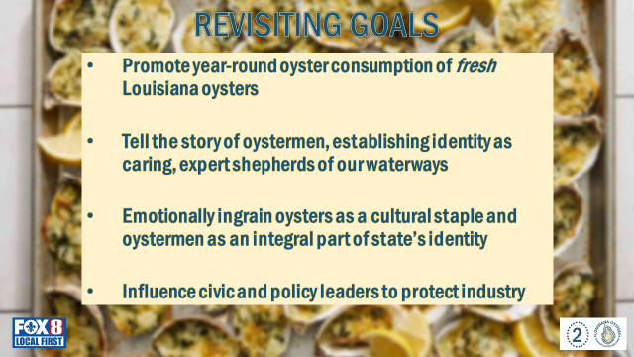

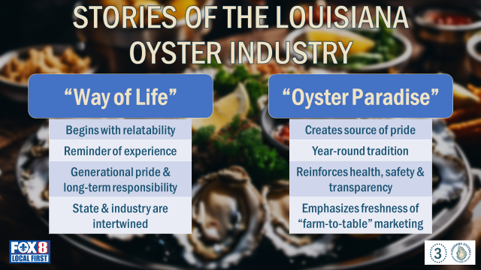

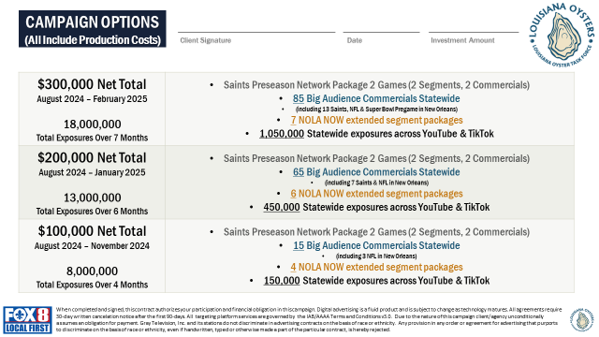

Mitch Jurisich stated that the industry can tweak the script and what’s presented here; Sam Slavich stated that carbon sequestration is another good point to possibly make here

Mitch Jurisich stated that the task force needs some time to consider this, would like to negotiate some of these packages and perhaps bring this back up for consideration at a future meeting

Jakov Jurisic stated that this should go to the marketing committee, other avenues need to explore would like to see if the SPMB would like to participate in this as well

Al Sunseri stated that he would like to give the chair the permission to negotiate these packages and come back to the task force with the final product

1. The task force considered funding and participation in the 2025 LA Alive event in Washington, D.C.

Brad Robin motioned to approve $11,000 in fundingto sponsor a booth at the 2025 LA Alive event, 2nd by Brandt Lafrance. Motion carries.

1. The Task force postponed discussion at this time on considering funding for a documentary that covers the BP Oil Spill and the aftermath

**VII.** Public Comment

Gene Cavalier stated that Shellfish Crop Insurance Program, is doing a pilot program on farmed oysters, LA is off of the list, as we do not have the ability, plans to look further into the USDA as to why the State is not involved in this shellfish program, Certified LA label, has 700 businesses who are participating in the certified program total of around $55, *add a presentation for next meeting Kelly

Rusty Gaude stated that surveying for rangia clam in the corridor, abundant all over the marsh, looking at population of clams south of the closure line, incidental findings from oyster assessments, out of time and money can only look at that corridor working his way down from the temple all the way down to Grand Isle, where they are and where the clams stop, went to VA and got the VA health department to do HACCP plan for clams, asking the industry that if anyone is picking up rangia clams while they are harvesting would like to know where this is, can now bring into commerce regular shellfish protocol, looking at this for the next three years, looking for live not shell

Al Sunseri stated that Rusty Gaude should get in touch with Dan Coulon as he has a tremendous knowledge on the subject matter and could possibly help provide some feedback on this

**VIII.** The next Oyster Task Force meeting was set for Tuesday, July 23, 2024 for 10am Lakefront Aiport, a Marketing Committee meeting will be held prior to the full task force meeting 9am

**IX.** Brad Robin motioned to adjourn the meeting, 2nd by Sam Slavich. Motion carries.